November 15, 2017

Specialized Press Contact
Doris Hirsch
Performance Materials
Phone +49 6151 18-4079
doris.hirsch@evonik.com

Yong Liu
Marketing Application Monomers
Performance Materials
Phone +86 6119 1315
yong.liu@evonik.com

Evonik Performance
Materials GmbH
Rellinghauser Straße 1-11
45128 Essen
Germany
Phone +49 201 177-01
Fax +49 201 177-3475
www.evonik.com
Supervisory Board:
Dr. Harald Schwager, Chairman
Managing Directors
Johann-Caspar Gammelin, Chairman
Dr. Michael Pack,
Magdalena Wagner,
Rainer Wobbe

Registered Office Essen
Register Court
City Local Court Essen
Commercial Registry B 25779
2017 ChinaCoat, Hall W3, Booth D05-12

Focus on customer needs: Evonik presents its methacrylate monomers at 2017 ChinaCoat

- Broad methacrylates portfolio for the coatings industry
- Focus on customer needs and customized monomers
- Newly aligned business line presents itself for the first time at ChinaCoat

Shanghai, China. Evonik is focussing on the needs of the customer in the coatings industry and will present its methacrylate monomers at the 2017 Shanghai ChinaCoat from November 15 to 17, 2017. Whether methacrylate-based resins for large-scale applications such as architectural and automotive coatings or applications such as reactive adhesives: Evonik has the competency and the products to give resins specific and customized properties. On request, the methacrylate experts also develop completely new components right up to the production stage, or finished products in accordance with the customer’s specifications.

VISIOMER® monomers are on display at the Evonik booth in hall W3, booth D05-12. They offer a unique modular system for tailoring desired product properties in various end-use applications for the coatings and resins industry. Monomers such as VISIOMER® MMA, n-BMA and i-BMA provide very good weather durability. VISIOMER® GMAA is used as a building block in paints and confers specific properties such as improved freeze-thaw resistance, colloidal stability in emulsion, and enhanced film adhesion to the product.

Tried-and-tested solution provider for all kinds of requirements
With China’s stronger focus on environmental issues, water-borne coating and resin solutions are widely sought after by local coating/resin manufacturers. Evonik methacrylate monomers like VISIOMER® AMA, EGDMA and 1,4-BDDMA can play a key role in core-shell emulsion synthesis to meet the performance needs of water-borne coatings. For the Chinese market, we have also developed water-borne latex (VISIOMER® C13-MA) with excellent waterproof properties.

The methacrylate monomers portfolio also contains methacrylates for the fast-growing industries of OEM and refinish coatings (VISIOMER® EHMA, HEMA), elastic coatings for architectural exterior/interior (VISIOMER® MAAmide ), 3C and plastics coatings (VISIOMER® C13-MA), and even the trendy 3D printing industry (VISIOMER® HEMATMDI). The range of its product portfolio and its development, and the production competency make Evonik one of the world’s leading suppliers of methacrylate.

Greater focus on customer needs
In recent months the methacrylate business in the Evonik Performance Materials Segment has been realigned to ensure a greater customer focus. The Bulk Monomers Product Line supplies high-volume monomers from a single source: MMA, GMAA, nBMA, iBMA, HEMA and HPMA. The newly established Application Monomers Product Line is now a solutions provider for specialty monomers.

“We can now address the special requirements of our customers even better than before,” states Martin Trocha, global head of the Application Monomers Product Line. Thanks to their decades of experience in production and innovation, their knowledge of the market, and their global alignment, the Evonik specialists have developed an in-depth understanding of methacrylate chemistry in the coatings area. As a solution provider and partner, the Methacrylates Business Line provides its customers with an “all-round service package.” “We offer a broad product portfolio with more than 50 specialty products and also the ambition to develop individual solutions. We manufacture in China, Germany and the USA, we have a presence in all the key countries worldwide, and thus maintain close contact with our customers. This enables us to recognize at an early stage what the customers need, what the trends and developments are in the coatings industry, and to search for new solutions,” says Tae Seok Yang, Asia head of the Product Line.

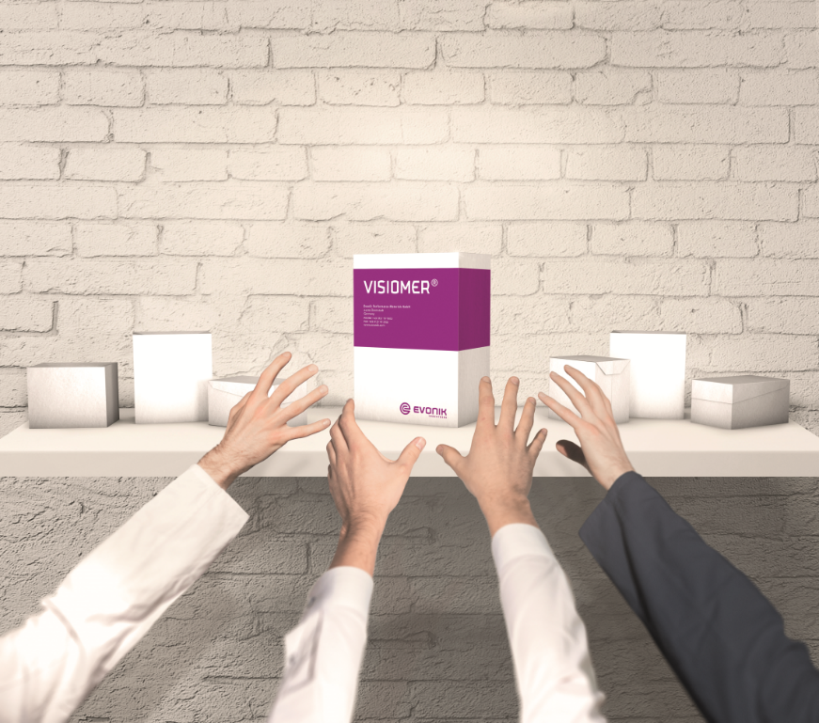
Caption:
The portfolio of VISIOMER® includes more than 50 monomers, offering a versatile toolbox to solve literally any challenge.

Company information
Evonik is one of the world leaders in specialty chemicals. The focus on more specialty businesses, customer-orientated innovative prowess and a trustful and performance-oriented corporate culture form the heart of Evonik’s corporate strategy. They are the lever for profitable growth and a sustained increase in the value of the company. Evonik benefits specifically from its customer proximity and leading market positions. Evonik is active in over 100 countries around the world with more than 36,000 employees. In fiscal 2016, the enterprise generated sales of around €12.7 billion and an operating profit (adjusted EBITDA) of about €2.165 billion.

About Performance Materials
The Performance Materials Segment is managed by Evonik Performance Materials GmbH. The segment focuses its global activities on developing and manufacturing polymer materials and intermediates, especially for use in agriculture and in the rubber and plastics industry. In 2016, the segment’s roughly 4,400 employees generated sales about €3.2 billion.

Disclaimer
In so far as forecasts or expectations are expressed in this press release or where our statements concern the future, these forecasts, expectations or statements may involve known or unknown risks and uncertainties. Actual results or developments may vary, depending on changes in the operating environment. Neither Evonik Industries AG nor its group companies assume an obligation to update the forecasts, expectations or statements contained in this release.

